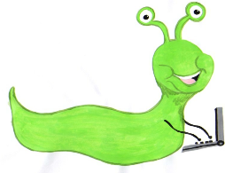

Lyng Primary School Knowledge Organiser

Computing

Topic: Computing



Autumn 2

Scratch – How can our computers be used to make music?

Year 5

|  |  |
| --- | --- |
| What Goldilocks and Step On words will I use? | |
| **Spelling** | **Defintion** |
| Bug | Mistake or error in the code stopping the program from working as intended |
| Debug | Remove or repair the error in computer code |
| Live loop | A repeated sequence of instruction that goes on forever. Multiple running at the same time |
| Pitch | Musical term – how high or low a note is |
| Rhythm | Musical term – pattern of long and short notes |
| Tempo | Musical term – speed |
| Timbre | Musical term – the characteristic trait of a sound |

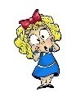

**Aims of this unit**

* Design, write and debug programs that accomplish specific goals, including controlling or simulating physical systems.
* Solve problems by decomposing them into smaller parts.
* Use sequence, selection and repetition in programs; work with variables and various forms of input and output.
* Use logical reasoning to explain how some simple algorithms work and to detect and correct errors in algorithms and programs.
* Use Scratch to create and debug:
* A simple tune
* Edit speed
* Edit instruments
* Multiple tunes simultaneously

**Safeguarding**

Filtering and monitoring system is in place. Children will use their own log in details to track any misuse and to protect the child from harmful websites and pop ups. Children will be reminded of how to stay safe online and to use technology safely and respectfully and to tell a trusted adult if there is anything on their computer that makes them uncomfortable. When using the iPads, the monitoring software will track which iPad has been used to enable us to know which class has used the iPad.

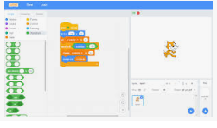

|  |
| --- |
| Outcomes |
| **All children**   * Move and edit blocks as part of an algorithm * Use the music extension   **Most children**   * Program an algorithm as a sequence of music instructions with actions and consequences linked to beats and pitch   **Some children**   * Add additional effects and features such as altering pitch, instrument, tempo and timbre. |

Autumn Term

Code using Scratch

**In this unit…**

The children will develop their own version of a song using Scratch code.

**Agreed outcome:**

Use Scratch to develop a song using music extension code.